CS 480
Software Requirements Specification

Document Control

Document Information
© | Information
Document Owner | Alex, Tony, Eduardo, Gerardo
Issue Date | 4/7/2026
Last Saved Date | 6/09/2026
File Name | SRS – Version 2.0 – Project 3

Table of Contents

1. Introduction 3
Purpose 3
Scope of the project 3
Glossary 4
References 4
Activity Diagram 5
2. Use Case Diagram 6
3. Use Case Descriptions 6
Register and Login 6
3..1. Use Case 1 Description 6
3..2. User interfaces 7
3..2.1. User Interface 1 7
Start Accident Report with AI Guidance 8
3..1. Use Case 2 Description 8
3..2. User interfaces 9
3..2.1. User Interface 2 9
3..3. API interfaces 10
3..3.1. API Call 2 10
Collect Accident Information 11
3..1. Use Case 3 Description 11
3..2. User interfaces 12
3..2.1. User Interface 3 12
Capture Photos 13
3..1. Use Case 4 Description 13
Save and Hash Record 14
3..1. Use Case 5 Description 14
3..2. User interfaces 15
3..2.1. User Interface 5 – Incident Report Review Screen 15
3..3. API interfaces 16
3..3.1. API Call 5- Firebase 16
View Incident Report 17
3..1. Use Case 6 Description 17
Manage Account 18
3..1. Use Case 7 Description 18
3..2. User interfaces 19
3..2.1. User Interface 7 19
4. Technology 19
User Interface 19
Database 20
Authentication 20

Introduction

Purpose
The purpose of this document is to define the software requirements for the Accident Record Preservation System, an Android mobile application designed to assist drivers in the aftermath of a vehicle accident. This document outlines use cases, system constraints, and design considerations for the application. The system will utilize an AI-powered assistant, emergency service integration, and tamper evident cloud storage through cryptographic hashing.

Scope of the project
In scope | Out of Scope
User able to log in | Accident outside of USA
User able to log out | User fabricating evidence
User able to change username, password | Full blockchain implementation
User able to use their camera to take picture | IOS version of the app
User able to see taken photos from the camera | Legal advice
User able to upload the file
Step by step guide accident flow
Collect involved parties’ information (such as insurance, vehicle)
Auto capture GPS location and timestamp
AI assistant (such as clarify the instruction)
One-tap emergency 911 call | AI incapable of 911 direct communication
Store sensitive information in database
SHA-256 information encryption
View saved incident history
Offline support | AI interaction, Cloud Upload

Glossary
- Android Studio: Integrated development environment (IDE) used to develop Android mobile applications
- API (Application Programming Interface: Protocols that allow two software applications to communicate with each other
- Authentication: The process of verifying the identity of a user before granting access to the system
- Cryptographic Hash: Fixed length string generated from input using a math function to verify data integrity
- Firebase: Backend as a service platform developed by Google that provides database, authentication, file storage, and hosting services
- GPS (Global Positioning System): Satellite based navigation system used to determine geographic location of a device
- Hit and Run: An accident scenario in which a party leaves the scene without providing their information
- Multi-party Accident: An accident scenario involving two or more vehicles and their respective drivers
- SHA-256 (Secure Hash Algorithm 256): Cryptographic hash function that gives a fixed 64 character hexadecimal string from any input, used to create tamper evident records
- Solo Accident: Accident scenario involving only one vehicle like colliding with a stationary object
- SOS: Distress signal feature in the application that initiates the emergency response flow and prompts the user to call 9116

References
CollectionReference | Firebase SDKs for Android. (2026). Firebase. https://firebase.google.com/docs/reference/kotlin/com/google/firebase/firestore/CollectionReference
Emergency Location Service. (n.d.). Android. https://www.android.com/safety/emergency-help/emergency-location-service/
FirebaseFirestore | Firebase SDKs for Android. (2026). Firebase. https://firebase.google.com/docs/reference/kotlin/com/google/firebase/firestore/FirebaseFirestore
FusedLocationProviderClient | Google APIs for Android. (n.d.). Google Developers. https://developers.google.com/android/reference/com/google/android/gms/location/FusedLocationProviderClient
MessageDigest (Java Platform SE 8 ). (n.d.). Docs.oracle.com. https://docs.oracle.com/javase/8/docs/api/java/security/MessageDigest.html
StorageReference | Firebase SDKs for Android. (2026). Firebase. https://firebase.google.com/docs/reference/android/com/google/firebase/storage/StorageReference

Activity Diagram
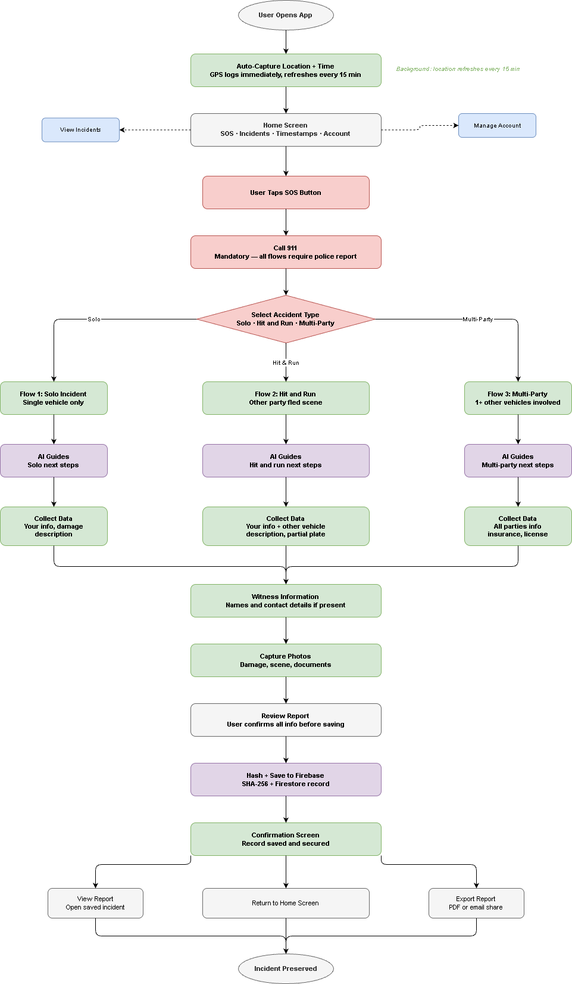

Use Case Diagram
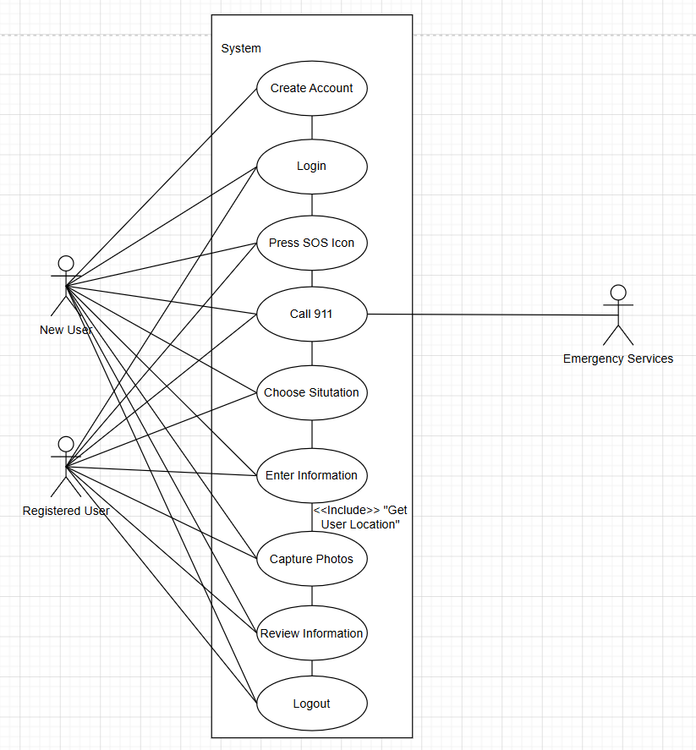

Use Case Descriptions

Register and Login

Use Case 1 Description
Use Case Name: | Register and Login
Use Case Id: | UC-01
Description: | Allow a new user to create an account or an existing user to access their profile to manage their incident history.
Priority: | High
Primary Business Actor: | User
Other Participating Actors: | ‘Firebase’ Authentication
Pre-Condition: | The app is installed on an Android device
Trigger: | The user opens the app for the first time or after they have logged out
Typical Course of Events: | Actor Action | System Response
 | - The user selects “Sign up” or “Login” | System should display input fields (Email and password; subject to change)
 | - The user enters their credentials and taps the confirm button. | System should send their credentials to the Firebase Authentication.
 | - System verifies the user’s login credentials | System grants access to the user and the user is navigated to the app’s main dashboard (where ‘sos’ button should be located)
Alternate Courses: | Actor Action | System Response
 | - User enters an email that is already registered. | The system should display an error like “Email already in use, please try again” and prompt for different email.
 | - User enters an incorrect pair of login credentials. | System will display something like “Invalid username or password, please try again” and prompt again for credentials.
 | - User forgets their password | System directs the user to reset the password via the registered email (assuming it exists)
Post-Condition: | The user is successfully authenticated and can proceed with preserving information and evidence.
Assumptions: | The user already has an active internet connection for authentication. User cannot register without internet (or celluar) connection.
Open Issues: | Should unregistered user be able to use app to dial 911?

User interfaces

User Interface 1


Data Item | Origin
Username | User
Password | User

Start Accident Report with AI Guidance

Use Case 2 Description
Use Case Name: | Start Accident Report with AI Guidance
Use Case Id: | UC-02
Description: | User initiates a new accident report. AI assistant helps provide step-by-step guidance to ensure all important information and evidence are collected safely and securely.
Priority: | High
Primary Business Actor: | User
Other Participating Actors: | Local AI Model, Google Play Services API (if allowed)
Pre-Condition: | User should be logged into the application and application has been granted the necessary permissions: Camera, Location, Microphone (If applicable)
Trigger: | User taps the “Sos” (Naming may change) on the main app dashboard screen
Typical Course of Events: | Actor Action | System Response
 | - User taps main “Sos” button. | System should initialize the local AI assistant.
 | - User selects (or states if voice integrated) the type of accident. | System logs the type of accident user selected and prompts the user to begin the first evidence selection step. Next may vary on user selection.
Alternate Courses: | Actor Action | System Response
 | - Device and/or app has no internet connection | System falls back to offline support. App will queue data collection for upload when connection re-established.
Post-Condition: | A new incident report draft should be created in the device local memory, the timestamp and GPS coordinate data are secured, and user is successfully transitioned into the next appropriate data collection process.
Assumptions: | User’s device has enough battery life to sustain use. User can interact with screen (or speaking with AI if applicable).
Open Issues: | Should app AI assistant be voice driven by default? Should the user have to enable it manually? How much AI control over the app? What data AI has access to?

User interfaces

User Interface 2

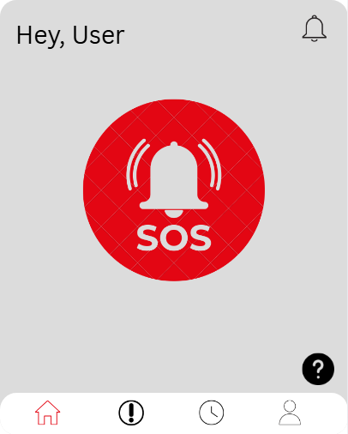
Data Item | Origin
N/A | N/A

API interfaces

API Call 2

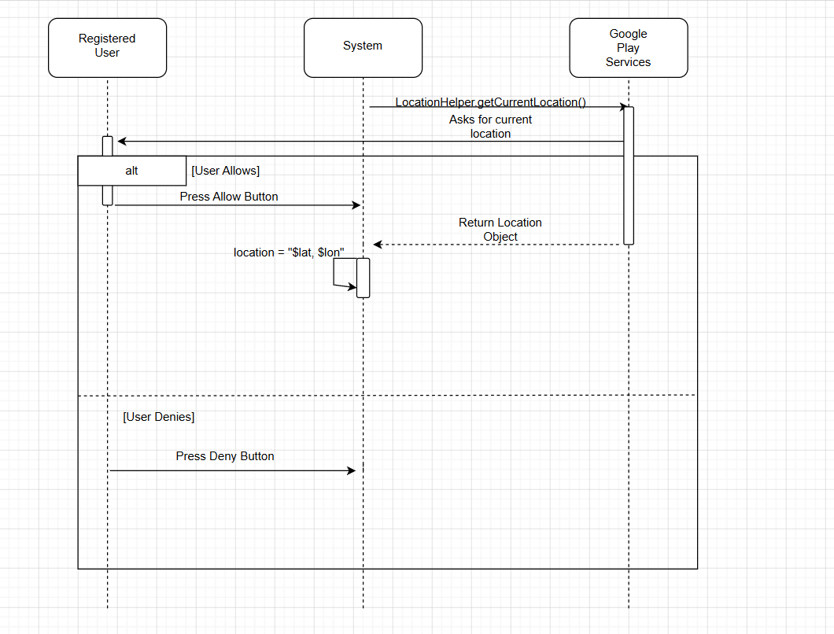

Data Items Sent to the API | Datatype and Size | Comments
N/A | N/A | N/A

Data Items Returned by the API | Datatype and Size | Comments
Location | Object{  latitude (Double),  longitude (Double),  accuracy (Float),  altitude (Double),  time (Long),  bearing (Float)  } | We will only be extracting the latitude and longitude values

Collect Accident Information

Use Case 3 Description
Use Case Name: | Collect Accident informatoin
Use Case Id: | UC-03
Description: | Allow the user to collect important information during an accident
Priority: | High
Primary Business Actor: | User
Other Participating Actors: | Camera
Pre-Condition: | App is installed, user already signed in, and they are currently in an accident
Trigger: | User click on the circle with an “i” in the middle
Typical Course of Events: | Actor Action | System Response
 | User click on the circle with an “i” in the middle | Display list of important question for the user to answer
 | User click on the “upload” | Display 2 options, camera and file, for the user to choose
Alternate Courses: | Actor Action | System Response
 | N/A | N/A
Post-Condition: | All the questions is answered and the questions require file are filled
Assumptions: | User able to type and take photos
Open Issues: | How should the app display the question so the user does not feel overwhelm?

User interfaces

User Interface 3

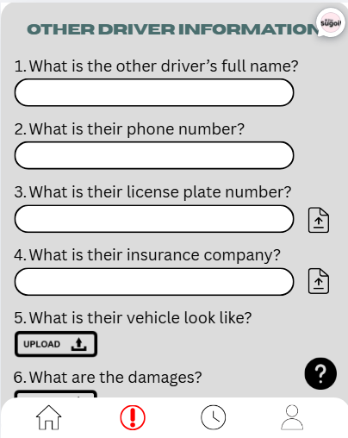
Data Item | Origin
Question answers | Users
File upload | Camera and user

Capture Photos

Use Case 4 Description
Use Case Name: | Capture Photo
Use Case Id: | UC-04
Description: | Allow the user to able to capture photo
Priority: | High
Primary Business Actor: | User
Other Participating Actors: | Phone camera
Pre-Condition: | App is installed, user already signed in, and locate the place to click “upload”
Trigger: | User click on “upload”
Typical Course of Events: | Actor Action | System Response
 | User click on “upload" and choose the camera option | Open the camera
Alternate Courses: | Actor Action | System Response
 | N/A | N/A
Post-Condition: | A picture is taken and upload to the right place
Assumptions: | Phone camera is working and user to able to take photo
Open Issues: | N/A

Save and Hash Record

Use Case 5 Description
Use Case Name: | Save and Hash Record
Use Case Id: | UC-05
Description: | When the accident report is completed, the system generates a SHA-256 cryptographic hash of the incident record and saves both the record and its hash to database.
Priority: | High
Primary Business Actor: | User
Other Participating Actors: | Firebase Storage, Firebase Firestore, Google Play Services API (if allowed)
Pre-Condition: | The user has completed filling out the accident report for the respective flow (solo, hit and run, or multi-party) and all required fields have been entered.
Trigger: | User taps “Save Report” button on the final review screen
Typical Course of Events: | Actor Action | System Response
 | User reviews completed report and taps “Save Report”
 |  | Systems compiles all collected incident data into a single string
 |  | System generates a SHA-256 hash of the compiled data
 |  | System uploads an attached photos to Firebase Storage
 |  | System writes the incident record under the Firebase Firestore authenticated user
 |  | System displays a confirmation message that the incident report has been saved
Alternate Courses: | Actor Action | System Response
 |  | If the device has no internet connection at time of save, the system saved the record locally with Firestore offline and uploads when connection is restored
 |  | If Firestore write fails, system will display error message and prompt user to try again and record is not lost
Post-Condition: | The incident record and its SHA-256 has are stored in the Firebase Firestore. Photos are stored in Firebase storage and the record can be retrieved and viewed.
Assumptions:
Open Issues: | - Need to determine what fields should be included in the hash  - Need to define the max photo file size and whether compression is applied before upload

User interfaces

User Interface 5 – Incident Report Review Screen

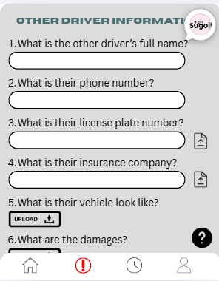
Data Item | Origin
Driver name | Entered by user
License plate | Entered by user
Insurance provider and policy number | Entered by user
Data and Time of incident | Auto-captured by system
GPS location coordinates | Obtained from Google Play Services API if allowed
Attached photos (thumbnails) | Captured by user
Other party info | Entered by user
Witness name and contact | Entered by user
Accident Type | Entered by user

API interfaces

API Call 5- Firebase
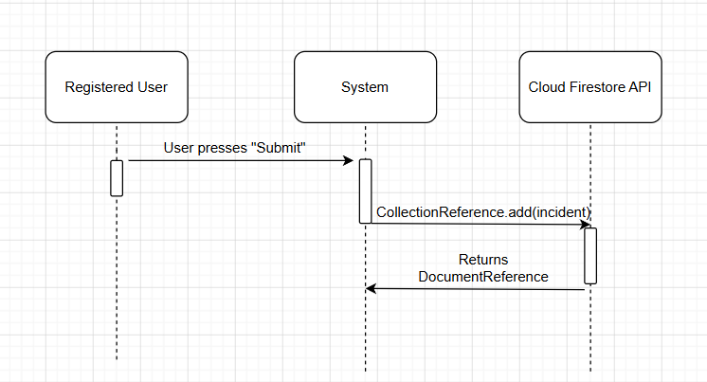

Data Items Sent to the API | Datatype and Size | Comments
User UID | String, max 128 chars | Retrieved from Firebase Authentication
Incident ID | String, max 128 chars | Auto generated by firestore
Driver name | String, max 128 chars | Entered by User
License number | String, max 28 chars | Entered by User
Insurance info | String (or JSON) | Entered by User
Date of incident | Date | Entered by User
Time of incident | Time | Entered by User
GPS coordinates | Object or String, ~30-50 chars | Obtained from Google Play Services API if allowed
Accident type | String | “Solo”, “hit and run”, “multiparty”
Other party info | String or Object | Null if solo
Witness info | String or Object | Null if no witnesses
Photos | Base64 String | Retrieved from User
Timestamp | Timestamp | Auto generated
Photo file to Storage | JPEG or PNG | compressed

Data Items Returned by the API | Datatype and Size | Comments
Document reference ID | String, max 128 chars | Firestore auto generated incident id

View Incident Report

Use Case 6 Description
Use Case Name: | View Incident Report
Use Case Id: | UC-06
Description: | Allows the user to browse their accident report history and view details of it: photos, timestamps, GPS coordinate data to all be used for insurance or legal purposes.
Priority: | Medium
Primary Business Actor: | User
Other Participating Actors: | ‘Firebase Firestore’, ‘Firebase Storage’
Pre-Condition: | The user should already be authenticated and has at least one incident record that has been successfully saved and hashed securely.
Trigger: | The user selects “view incident history” (subject to change) or selects a specific report from the app dashboard.
Typical Course of Events: | Actor Action | System Response
 | - User taps on the “Incident History” icon in the app. | System should query the Firebase Firestore for all records associated with that specific user’s ID.
 | - The user selects a specific incident from the list. | System retrieves the full data record and associated photo (or video) URLs.
 | - User views the report details. | The system shows the compiled data (like driver's name, license plate, GPS coordinates, etc.) and renders the captured photos and/or videos
Alternate Courses: | Actor Action | System Response
 | - The device (and therefore app) is offline. | System retrieves what records it can from the local Firestore cache if it was previously synced.
 | - User tries to view a record with a corrupted hash. | System should alert the user something like “Tampering check failed” to indicate the file’s hash was either overwritten or modified.
Post-Condition: | The user has successfully reviewed the preserved evidence from their past accident.
Assumptions: | The cryptographic hash that is stored in the database remains consistent with the compiled record data.
Open Issues: | Should app allow users to export reports to PDF directly to share with insurance or law enforcement?

Manage Account

Use Case 7 Description
Use Case Name: | Manage Account
Use Case Id: | UC-07
Description: | Allow the user to manage their account
Priority: | Medium
Primary Business Actor: | User
Other Participating Actors: | ‘Firebase Firestore’, ‘Firebase Storage’
Pre-Condition: | App is installed and user is already signed up
Trigger: | User click on the human icon on the bottom right
Typical Course of Events: | Actor Action | System Response
 | User click on “Account” | Display edit profile screen
 | User click on “General” | Display personal information such as insurance, vehicle number, etc
 | User click on “App Preferences” | Display list of App behaviour for the user to change such as Notification, Dark Mode, etc
 | User click on “Privacy & Permission” | Display list of permission needed for the app to run such as camera permission
 | User click on “Support” | Display frequency ask question. In our case would be question and answer about the app basic function
Alternate Courses: | Actor Action | System Response
 | N/A | N/A
Post-Condition: | User change their email, password, personal information, app behaviour, and app permission.
Assumptions: | User about to navigate the setting location
Open Issues: | Do we need the support function?

User interfaces

User Interface 7

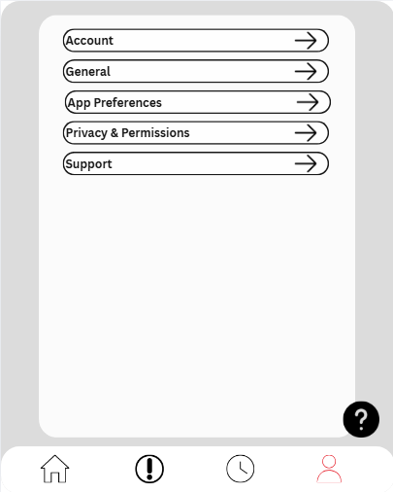
Data Item | Origin
Content inside Account | Firebase
Content inside General | Firebase

Technology

User Interface
Technology | Reason
Kotlin | Google declare as “Official language of Android Development”
 | NullPointerExceptions lower than JAVA
 | Same level of maintainability as JAVA
 | Concise and expressive syntax and multiple features
 | Support multiplatform development

Database
Technology | Reason
Firebase Cloud Firestore | Backend as a service platform that provides a free tier and imposes no licensing restrictions for academic use.
 | Offers Android SDK with full Java support
 | No need to build, host, or maintain a separate backend server with photo/file storage
 | Has firebase authentication, reducing the number of 3rd parties
 | Offline persistence
Since it’s not a relational database we don’t need tables, rows, and instead the information is organized into collections of documents
It would be a hierarchical data structure so we have
Users/ as the top level

Incidents / as a subcollection
 | Android studio provides built in tooling and Firebase integration for Kotlin projects

Authentication
Technology | Reason
Firebase Authentication | Firebase handles all the credential storage, password hashing, and session management server side
 | User authenticate using email address and password and when they are registered they are given a unique UID for each account and this UID is used throughout the application as the primary key
 | Authentication state persists across app restarts – users stay logged in until they sign out

